2. Create a new Facebook business page and post omen social media poster for your brand

Coffee shop

Design shot:

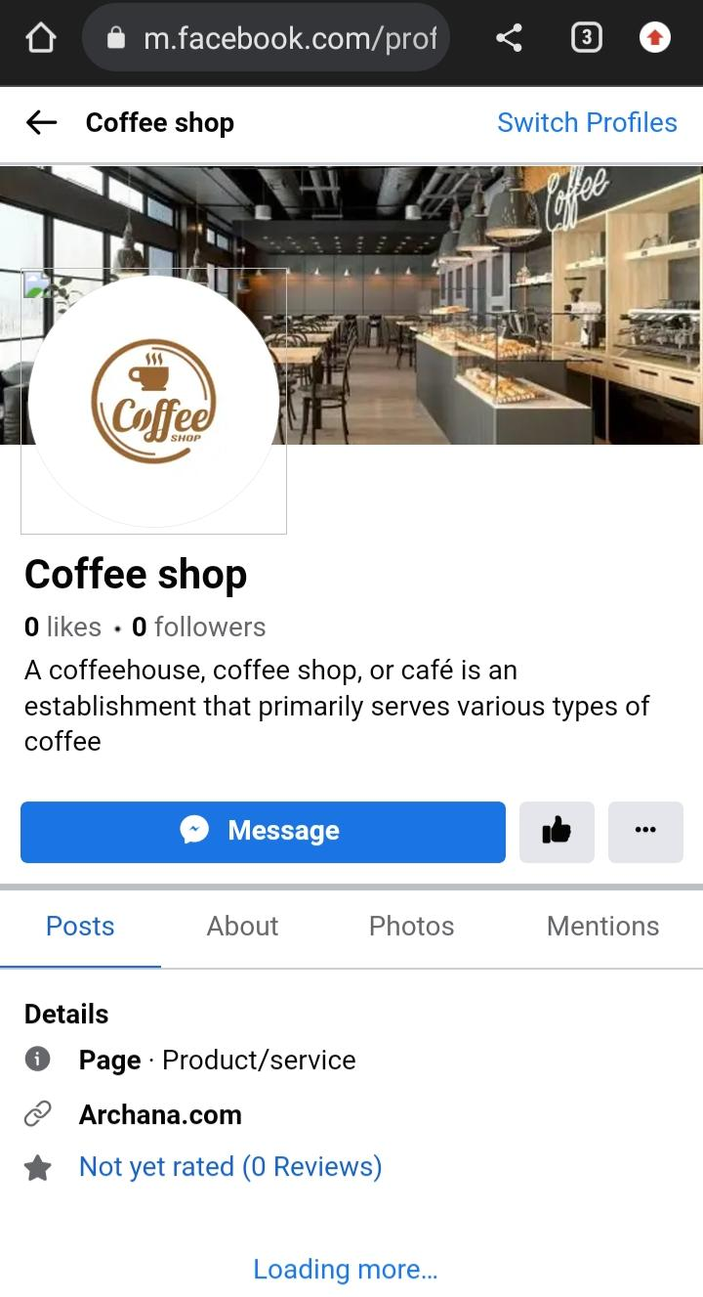Design link: <https://m.facebook.com/profile.php/?id=61552521732501>